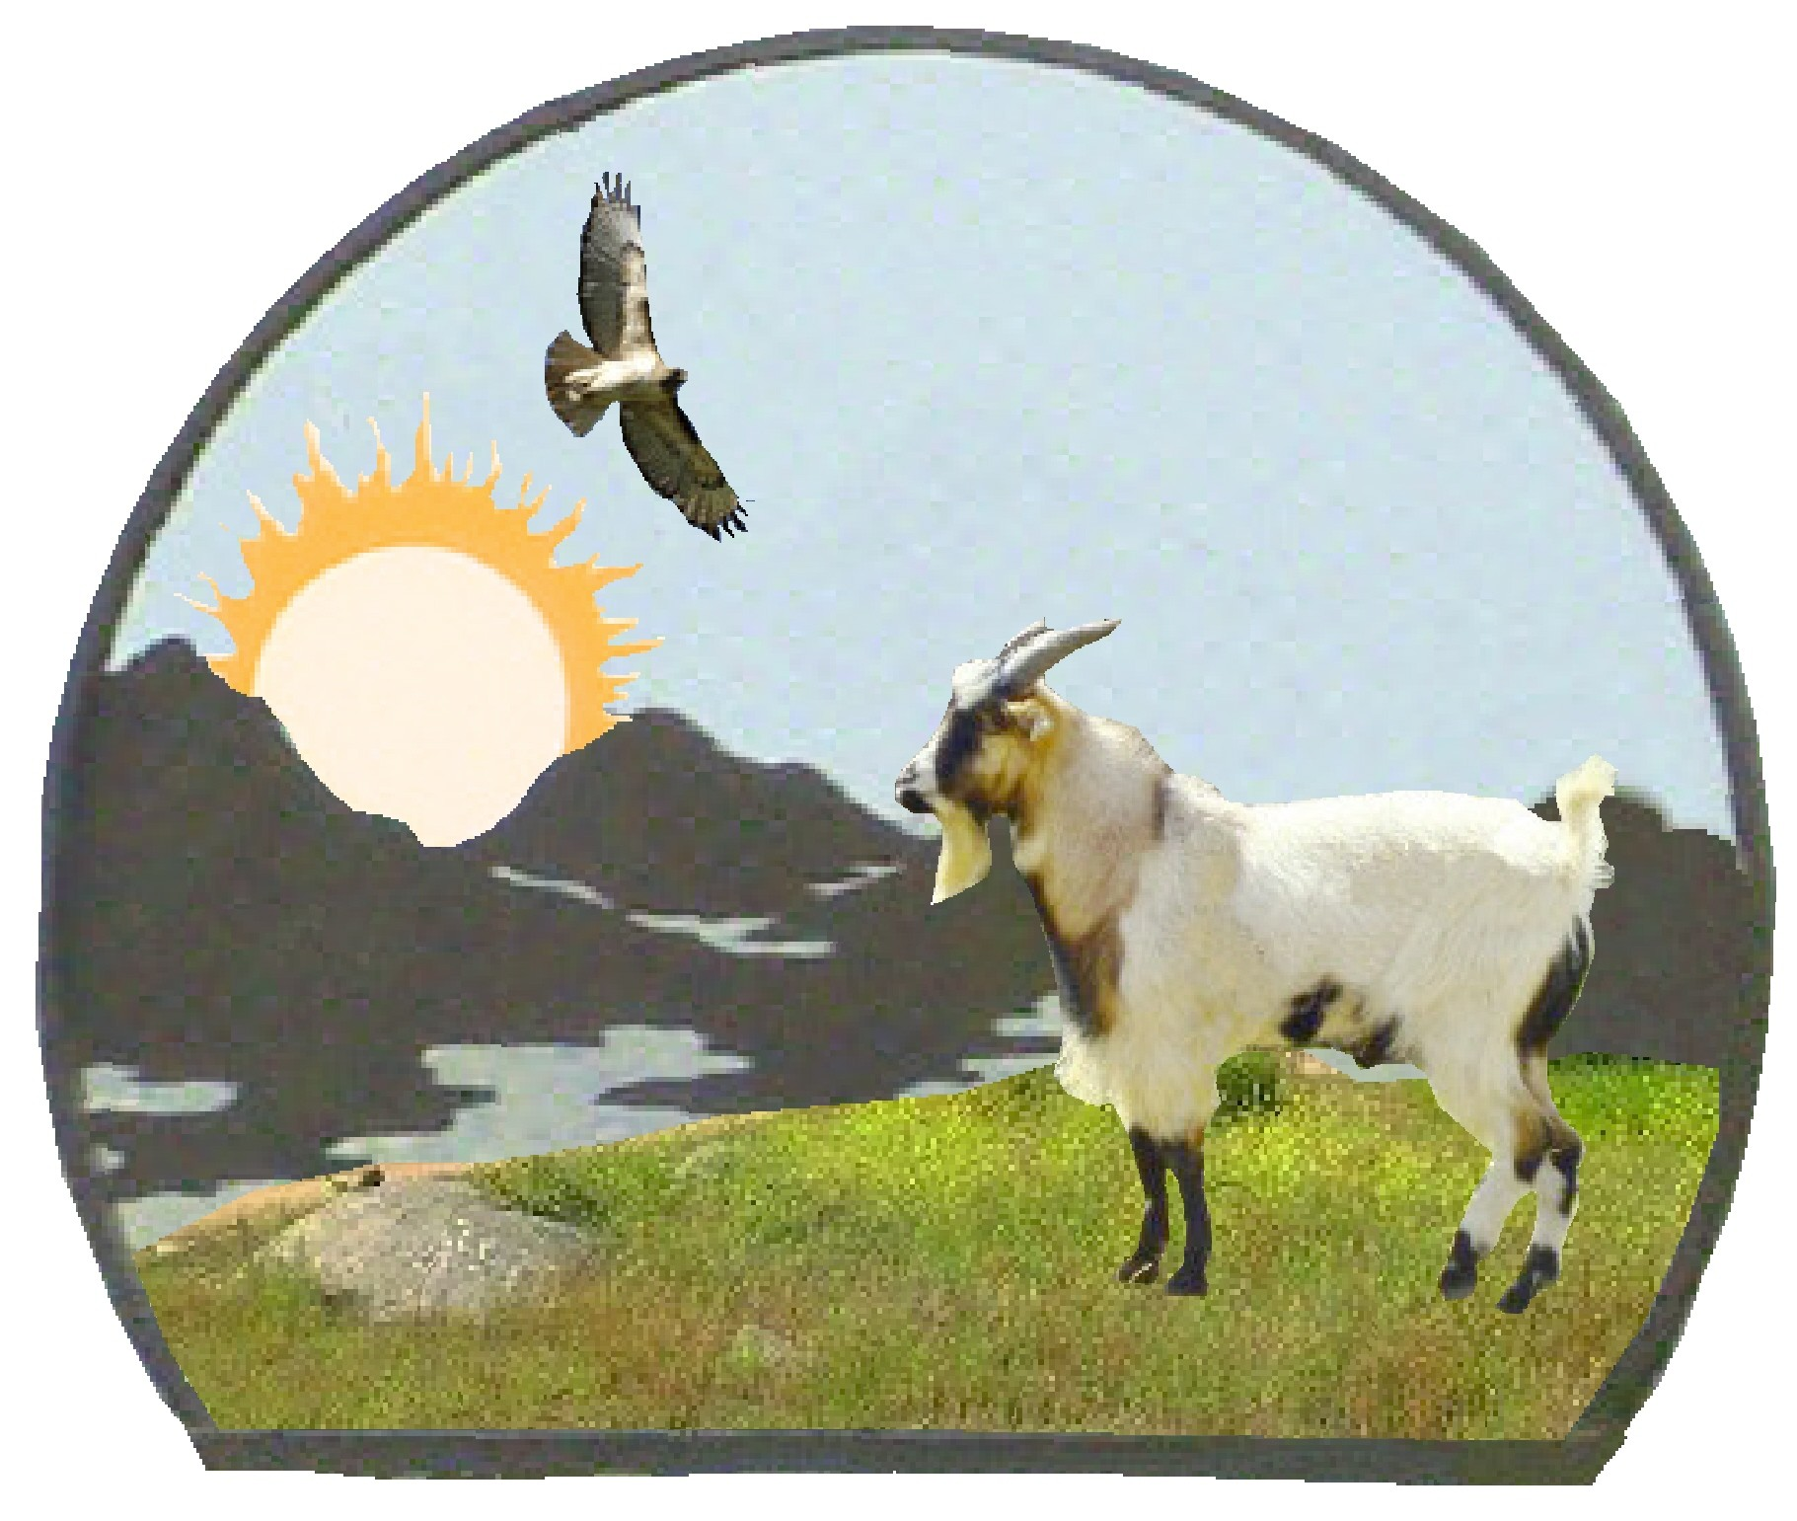 | 7th Annual  Valley of the Sun Fainting Goat Show  October 16 - 17, 2015

Sponsor Form

We would greatly appreciate your support. We cannot succeed without you!!!

Name (or Company Name): ________________________________________________________

Address: _______________________________________________________________________

Phone: _________________________________ Email: _________________________________

I would like to Sponsor the following [check appropriate box(es)]:
Check Box(es)
$100 - Best in Show Sponsors
Full Page ad in Show Program and website
$50 – Grand Champion Sponsors
Half Page ad in Show Program and Full Page ad on website
Upgrade to Full Page ad in Show Program with the purchase of 2 Grand Champion Sponsorships
$25 - Champion Sponsors
Quarter Page ad in Show Program and Full Page ad on website
Upgrade to Half Page ad in Show Program with the purchase of 2 Champion Sponsorships
 | Show Donations (Every bit helps!)  Name listed on website with a link to your business website, as well as name listed in Show Program. | Specify donation:

If your first choice is already assigned, we will drop to your second and so forth. You will be notified of your sponsored class. If all choices are taken, we will contact you for further instructions.
Ads must be received by September 30, 2015 to be printed in the Show Program.
Please make checks payable to T. Teichert. Mail check and Sponsorship form to Tracy Teichert, PO Box 1211, Ramona, CA 92065. If you have any questions, please contact the show secretary, Tracy Teichert, by email at tracy@ttt-ranch.com or by phone at (760) 468-2004 (cell phone).

Thank you for your support in promoting this incredibly wonderful breed of goat!

